Homework 2 for GPI
The number in front of ( ) is the number in KK’s 1st edition; The number inside the ( ) is the number in KK’s 2nd edition
- Two vectors are parallel (angle between them is zero) if the components are proportional to each other, i.e. 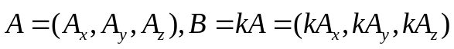, prove that A,B are parallel using dot and cross product.
- KK’s 1.3 （1.4 in 2nd edition）
- KK’s 1.4 (1.5 in 2nd edition)
- Prove the relation 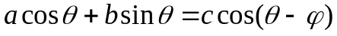,
where 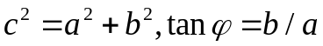, prove this using vector algebra instead of trigonometry。 （Hint: thinking about dot product between vectors）
- KK’s 1.8 (1.9)
- KK’s 1.9 (1.11)
- Is (AXB)XC=AX(BXC) true? Prove it if it’s true; if not provide a counter example. Also prove that (of course if you proved the later relation, you can use it to verify the true/false of the first)
- KK’s 1.11. Many ways doing this: You can prove this either geometrically or algebraically, a wise choice of coordinate axis will make the algebra simpler. Or even applying the triple cross product formula you proved in the previous problem
- KK’s 1.14
- Transformation of vectors:
- For rotational transformation, if the original vector is (2,1), after I rotate the coordinates counterclockwise by 30 degree, what is the vector’s expression in new coordinate system?
- The counterclockwise rotation of angleof coordinate system is given by matrix shown in (3-29) of my note; what is the matrix for clockwise rotation by? Show these two matrix are transpose to each other and one is the inverse of the other, which should be to make perfect physical sense.
- For the general transformation between orthonormal basis given by (3-33) of the note, show that the inverse transformation matrix is that given by (3-34) and use matrix multiplication to show explicitly that RR’=R’R=I.
- KK’s 1.19 (1.24 in 2nd) (essentially a cycloid as shown by the example in my note,)
- KK’s 1.20 ( 1.25) (needs polar coordinates)
- KK’s 1.21 (1.26)

